Steve Issazadeh

Mustafa Shahriar

Mohammad Ahmed

Fawad Asif

Team model that was used was the democratic team model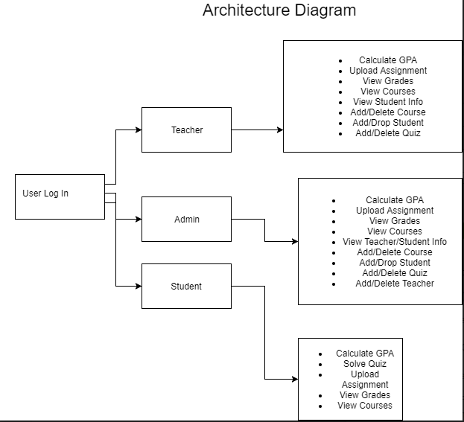

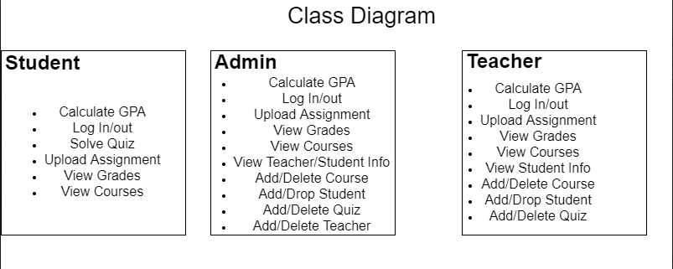

Use case diagram

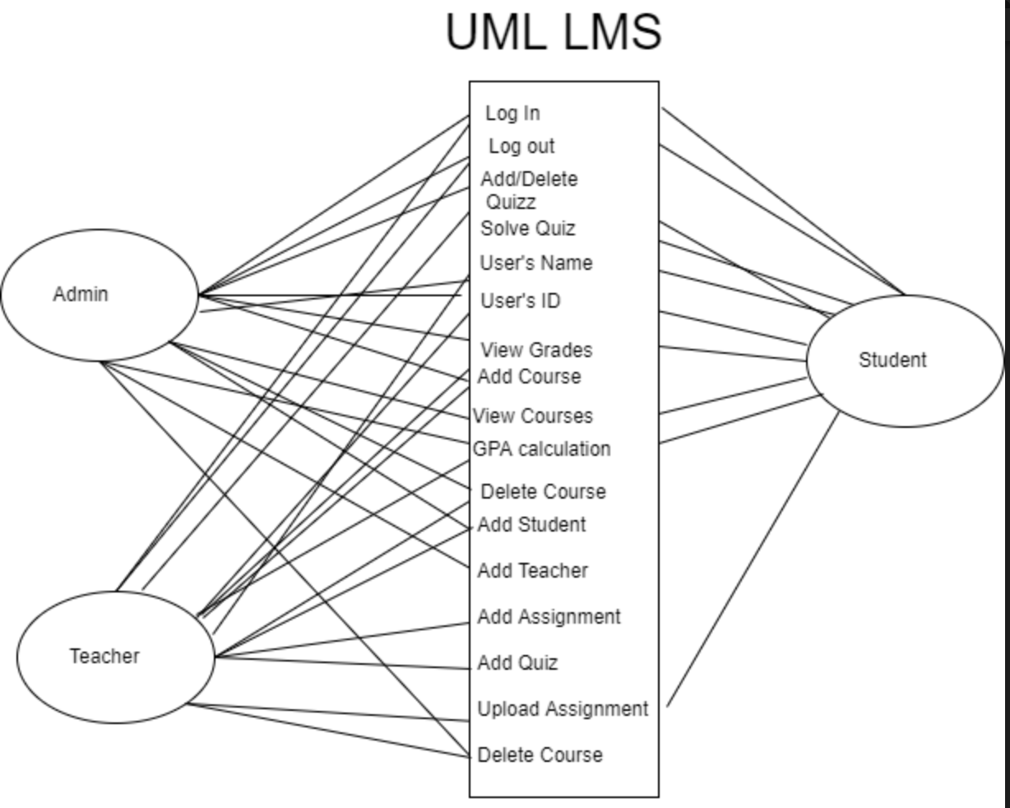

Github

https://github.com/jayspeed/SmartBoard